PURL SOHO MITTENS

materials

* ball of Purl Soho’s [Knitting Yarn](https://www.purlsoho.com/knitting-yarn.html), 100% merino wool. Each ball is 219 yards/ 100 grams; approximately 100 (125, 140, 180, 205) yards required. We used the colors Soft Sky, Flax Flower Blue, and Blue Whale.
* 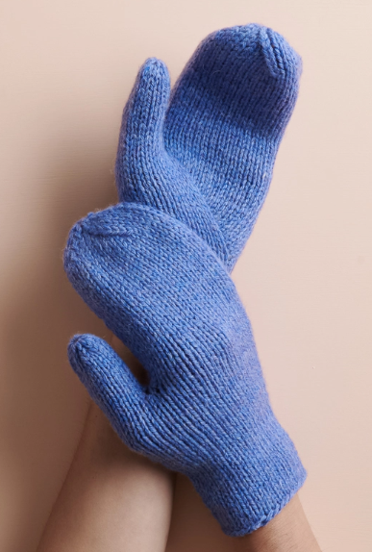A set of US 5 (3.75 mm) [double pointed needles](https://www.purlsoho.com/tools-and-notions/knitting-and-crochet.html?collection_filter=23799)
* [Stitch markers](https://www.purlsoho.com/tools-and-notions/knitting-and-crochet.html?collection_filter=964), including one unique
* [Stitch holder](https://www.purlsoho.com/tools-and-notions/knitting-and-crochet.html?collection_filter=23859) or scrap yarn

GAUGE

22 stitches and 28 rounds = 4 inches in stockinette stitch

SIZES

Kid (Adult Small, Adult Medium, Adult Large, Adult X-Large)

* Finished Circumference at Palm: 5¾ (6½,7¼, 8, 8¾) inches, comfortably stretching 2 inches
* Finished Length from Cuff to Tip: 8½ (9¾, 10¼, 11½, 12¼) inches, with instructions to modify

SAMPLES: The Soft Sky mittens are Kid size, the Flax Flower Blue mittens are Adult Small, and the Blue Whale mittens are Adult Medium.

PATTERN

CUFF

Cast on 31 (35, 39, 43, 47) stitches, distributing them onto 3 double pointed needles. We used a basic [Long Tail Cast On](https://www.purlsoho.com/create/long-tail-cast-on/).

Place a unique marker and join for working in the round, being careful not to twist the stitches.

Work in stockinette stitch, knitting each round, until piece measures 2 (2¼, 2½, 3, 3) inches from cast-on edge.

THUMB GUSSET

RIGHT MITTEN ONLY

Set-Up Round: K15 (17, 17, 19, 19), place marker (pm), knit to end of round.

Round 1: Knit to marker, slip marker (sm), [make 1 left](https://www.purlsoho.com/create/make-one-right-m1r-make-one-left-m1l/), knit to end of round. [1 stitch increased]

Repeat Round 1 fourteen (16, 16, 18, 18) more times. [46 (52, 56, 62, 66) stitches]

Next Round: K14 (16, 16, 18, 18), place previous 13 (15, 15, 17, 17) stitches onto stitch holder or scrap yarn, k1, remove marker, knit to end of round. [33 (37, 41, 45, 49) stitches remain]

Next Round: [Slip slip knit](https://www.purlsoho.com/create/slip-slip-knit-ssk/) (ssk), joining first stitch of Gusset to last stitch of Gusset, knit to end of round. [32 (36, 40, 44, 48) stitches remain]

LEFT MITTEN ONLY

UPDATE December 6, 2022: We’ve changed the wording of the Set-Up Round to be a bit clearer, right below. Don’t worry, the outcome is still the same!

Set-Up Round: K17 (19, 23, 25, 29), pm, knit to end of round.

Round 1: Knit to marker, [make 1 right](https://www.purlsoho.com/create/make-one-right-m1r-make-one-left-m1l/), sm, knit to end of round. [1 stitch increased]

Repeat Round 1 fourteen (16, 16, 18, 18) more times. [46 (52, 56, 62, 66) stitches]

Next Round: Slip previous 13 (15, 15, 17, 17) stitches onto stitch holder or scrap yarn, knit to marker, sm, slip next stitch purlwise onto right needle, remove end-of-round marker, replace slipped stitch back to left needle, replace remaining marker with end-of-round marker. [33, (37, 41, 45, 49) stitches remain]

Next Round: [Knit two together](https://www.purlsoho.com/create/knit-two-together-k2tog/) (k2tog), joining first stitch of Gusset to first stitch after Gusset, knit to end of round. [32 (36, 40, 44, 48) stitches remain]

PALM

Work in stockinette stitch, knitting each round, until piece measures 3 (3½, 3¾, 4, 4½) inches from end of Thumb Gusset, or until ⅞ (1, 1⅛, 1¼, 1⅜) inches from desired finished length.

MITTEN TOP

Set-Up Round: K12 (13, 15, 16, 18), pm, k4 (5, 5, 6, 6), pm, k5 (6, 6, 7, 7), pm, knit to end of round.

Round 1: Knit to 2 stitches before next marker, k2tog, sm, knit to next marker, sm, knit to next marker, sm, ssk, knit to end of round. [2 stitches decreased]

Round 2: K1, k2tog, knit to 2 stitches before next marker, k2tog, sm, knit to 2 stitches before next marker, ssk, sm, k1, k2tog, knit to next marker, sm, ssk, knit to 2 stitches before end of round, ssk. [6 stitches decreased]

Repeat Rounds 1 and 2 two (2, 3, 3, 4) more times, removing markers on the last round. [8 (12, 8, 12, 8) stitches remain]

SIZES ADULT SMALL + LARGE ONLY

Next Round: K1, k2tog, k1, ssk, k1, k2tog, ssk, k1. [8 stitches remain]

ALL SIZES

Cut yarn and thread it through remaining stitches.

THUMB

Slip 13 (15, 15, 17, 17) on-hold stitches onto 3 double pointed needles.

Hold mitten so thumbhole is on the left and join yarn to front needle.

Knit all 13 (15, 15, 17, 17) stitches, and before joining in the round, pick up 1 stitch from base of Thumb. [14 (16, 16, 18, 18) stitches]

Place marker and join for working in the round.

Knit until piece measures 1¾ (2, 2, 2¼, 2¼) inches from base of Thumb or until just shy of desired finished length.

Next Round: *K2tog, repeat from * to end of round. [7 (8, 8, 9, 9) stitches remain]

Cut yarn and thread it through remaining stitches.

FINISHING

Weave in ends and gently wet block.