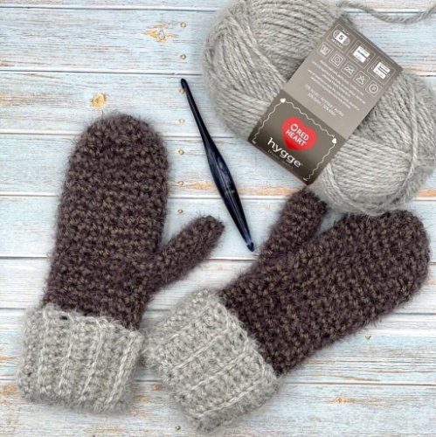Madsen Mittens - by Ashley Edmonds

(Crocheted Flat Cuff then in the Round)

Materials

* Approx. 150 of #5 Bulky weight yarn. I used *[Red Heart Hygge](https://amzn.to/3rwRxcc) C1 Cuff Colourway: Cloud C2 Hand Colourway: Sterling
* US size K/10.5 – 6.5mm crochet hook. I used my *[Furls Streamline Hook](https://shrsl.com/3ab5b)
* *[Scissors](https://amzn.to/3devyOL)
* *[Yarn needle](https://amzn.to/3mLwpsK)
* *[Stitch Markers](https://amzn.to/3lqL6mY)

### Difficulty - Easy

### Gauge - 6 sts x 7 rows = 2″ square Pattern for gauge: sc

### Size

Adult Small/Medium for free below: Approx. 14″ long and 4″ wide, laid flat no stretch, not cuffed Adult Medium/Large also available in the premium PDF available on Etsy and Ravelry

Stitch Abbreviations

* ch(s) – Chain(s) sc – Single Crochet
* scblo – Single Crochet Back Loop Only hdc – Half Double Crochet
* 2tog – Crochet 2 Together chsp – Chain Space
* slst – Slip Stitch st(s) – Stitch(es)
* sk – Skip C1 – Colour 1
* C2 – Colour 2 *__* – Denotes repeat sequence

Pattern Notes

* US Terminology
* All beginning ch1 do not count as a stitch
* The size can be adjusted by adding additional rows to the cuff for circumference, and adding or subtracting rounds to the hand for length
* Pattern is worked flat for the cuff then seamed together, and worked in continuous rounds (do not join) for the hand
* The pattern is the same for right and left hand until indicated at the thumb hole portion
* When working the 2tog sts it will be worked with a sc and hdc together
* *-* denotes repeat sequence
* **Adult small/medium**

##### **CUFF**

* **With C1, Ch 16**
* **Row 1:**Sc into the second ch from the hook, and each ch across, ch1, turn (15).
* **Row 2:** Scblo into the first st, scblo in each st across, ch1, turn (15).
* **Row 3 – 20:** Repeat row 2.
* Bring the ends together and slst across to join the cuff. Ch1 to begin working the hand portion around the top of the cuff.

##### **HAND**

**Work in continuous rounds, place a stitch marker in the first st of each round, do not join at the end of the round,** **place the first st of the next round where your st marker is.**

**Rnd 1:**Hdc evenly around the cuff (20).

**Switch to C2**

**Rnd 2:** Hdc in the first st , sc in the next, *hdc in the next st, sc in the next* repeat around (20).

**Rnd 3:** Sc in the first st , hdc in the next, *sc in the next st, hdc in the next* repeat around (20).

**Rnd 4 – 7**: Alternate between rnds 2 and 3.

**Thumb Hole Right Hand**

**Rnd 8:**Hdc in the first st, sc in the next, hdc in the next, sc in the next, ch4, sk 3 sts, alternate hdc, sc in the remaining 13 sts (17 sts, 4 chs).

**Rnd 9:**Sc in the first st, hdc in the next, sc in the next, hdc in the next, (sc,hdc,sc) in the chsp, alternate hdc, sc in the remaining 13 sts (20).

Continue to rnd 10

**Thumb Hole Left Hand**

**Rnd 8:**Hdc in the first st, sc in the next, *hdc in the next st, sc in the next* repeat for a total of 13 sts, ch4, sk 3 sts, alternate hdc, sc in the remaining 4 sts (17 sts, 4chs).

**Rnd 9:**Sc in the first st, hdc in the next, *sc in the next st, hdc in the next* repeat for a total of 13 sts, (sc,hdc,sc) in the chsp, alternate hdc, sc in the remaining 4 sts (20).

**Rnd 10 – 18:** Alternate between rows 2 and 3. Do more or less rnds here to adjust for individual hand size.

**Rnd 19:**Sc in the first st, hdc in the next, sc in the next, hdc/sc2tog, hdc in the next st, sc in the next st, hdc in the next st, sc/hdc2tog, sc in the next st, hdc in the next, sc in the next, hdc/sc2tog, hdc in the next st, sc in the next st, hdc in the next st, sc/hdc2tog (16).

**Rnd 20**: Hdc in the first st , sc in the next, *hdc in the next st, sc in the next* repeat around, tie off leaving long tail for closing (16).

Using your long tail and yarn needle, weave around the top of the mitten and cinch closed. Weave in your end.

##### **THUMB**

**Work in continuous rounds, place a stitch marker in the first st of each round, do not join at the end of the round,** **place the first st of the next round where your st marker is.**

Join yarn at thumb hole opening, ch1.

**Rnd 1:** Sc evenly around the thumb hole (10).

**Rnd 2:** Sc in the first st, and each st around (10).

**Rnd 3 – 8:** Repeat rnd 2.

**Rnd 9:** Sc in the first st, and each st around, tie off leaving long tail for closing (10).

Using your long tail and yarn needle, weave around the top of the thumb and cinch closed.

Weave in all ends, and you’re done!